Decision Tree Classification
1. Introduction
A Decision Tree is a supervised learning algorithm that predicts a class by recursively splitting the dataset into smaller subsets. At each step, the algorithm selects a feature and a threshold value that best separates the classes. The recursive splitting continues until we reach a pure leaf node, meaning the node contains data points belonging to only one class.
2. Structure of a Decision Tree
• Nodes
Each internal node represents a question about a feature, such as:
$x_{0}≤5?$
• Branches
Branches represent the possible answers to the question (Yes/No).
• Leaves
Leaf nodes contain the final prediction (e.g., Green or Red), and no further splitting is needed.
3. Dataset
The dataset contains two features:
$x_{0}$(horizontal axis)
$x_{1}$(vertical axis)
4. Example of a Decision Tree Split

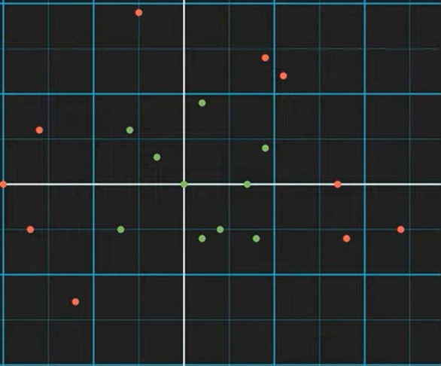
We start with the entire dataset (20 points)
First condition tested:
$$x_{0}≤-12$$

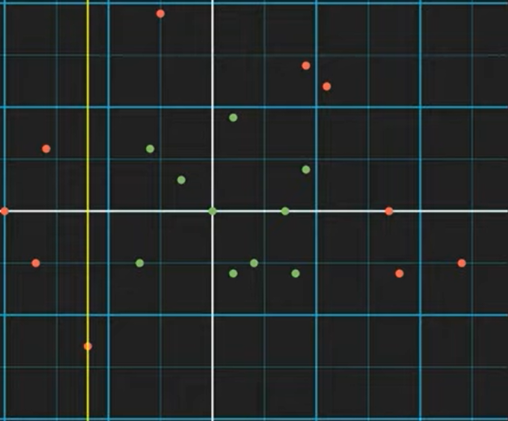
Case 1: YES branch
All samples satisfying $x_{0}≤-12$:
4 red 0 green
This is a pure red leaf node.
No further splitting is needed.
Case 2: NO branch
This contains the remaining data:
10 green 6 red

Second condition:
$$x_{0}≤9$$
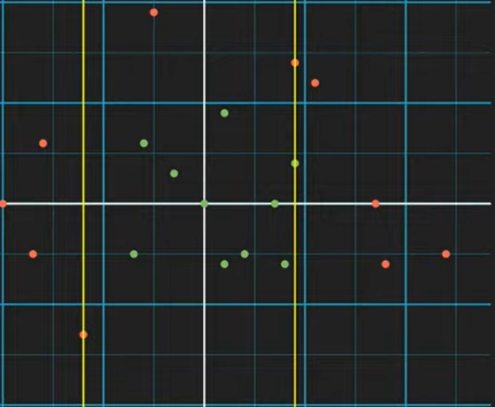
Case 2A: NO branch
4 red 0 green
This becomes a pure red leaf.
Case 2B: YES branch
This contains:
10 green 2 red

Third condition:
$$x_{1}≤9$$
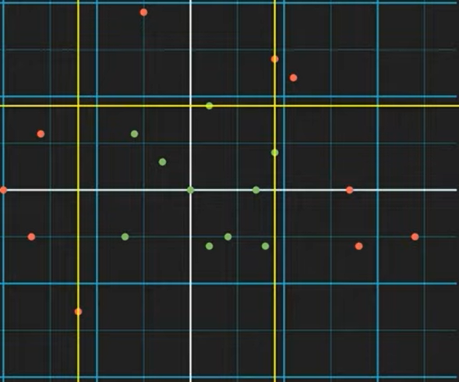
YES branch
10 green → Pure green leaf
NO branch
2 red → Pure red leaf
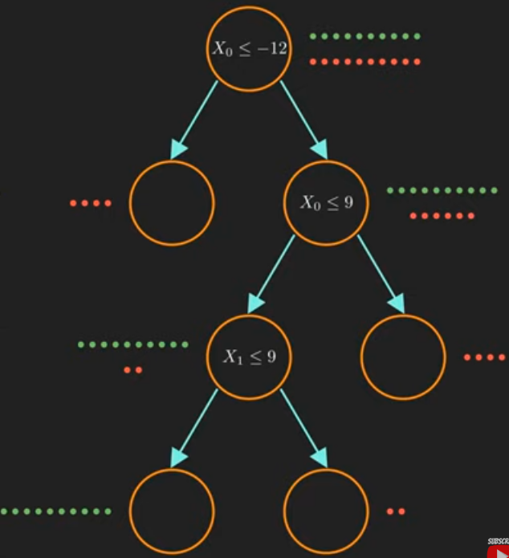
5. How the Decision Tree Learns (Information Gain)
The model evaluates all possible splits by searching for:
which feature to use
which threshold to choose
The objective is to maximize information gain (IG).
Entropy
Entropy measures impurity:
$$E=-\sum_{i}{p_{i}log⁡(p_{i})}$$
For the whole dataset:
10 green 10 red
$$E_{\text{parent}}=-0.5log⁡(0.5)-0.5log⁡(0.5)=1$$
Comparing Two Candidate Splits
Split 1: $x_{1}≤4$
YES group:
8 green 6 red
$$E_{1}=-0.57log⁡(0.57)-0.43log⁡(0.43)=0.99$$
NO group:
2 green 4 red
$$E_{2}=-0.33log⁡(0.33)-0.67log⁡(0.67)=0.91$$
Information Gain:
$$IG_{1}=1-(\frac{14}{20}0.99+\frac{6}{20}0.91)=0.034$$
Split 2: $x_{0}≤-12$
YES group:
4 red → pure
$$E_{1}=0$$
NO group:
10 green 6 red
$$E_{2}=-0.63log⁡(0.63)-0.37log⁡(0.37)=0.95$$
Information Gain:
$$IG_{2}=1-(\frac{4}{20}0+\frac{16}{20}0.95)=0.24$$
Conclusion of the Split
$$IG_{2}>IG_{1}$$
Therefore, the model chooses the condition:
$$x_{0}≤-12$$
as the best root split.

